**Project: General E-Commerce Website – API Integration Process**

**Developer: Ashbah sami**

**Date: Day 3**

**This document provides a step-by-step guide to integrating APIs into the general e-commerce website project. The integration includes setting up the environment, fetching data from the Sanity CMS, and displaying it dynamically on the website.**

**API Integration Steps**

1. **Cloning the Repository**
2. **Open a terminal or command prompt.**
3. **Clone the repository by running:**

**Git clone <repository-url>**

1. **Navigate to the cloned folder:**

**Cd <repository-folder>**

1. **Setting Up the Environment**
2. **Create an .env file in the root of the cloned project folder.**
3. **Add the following environment variables to the .env file:**

**SANITY_PROJECT_ID=<your-sanity-project-id>**

**SANITY_DATASET=<your-dataset-name>**

**SANITY_TOKEN=<your-sanity-token>**

**These values can be obtained from Sanity project settings.**

1. **Save the file.**
2. **Importing Data into Sanity**

* **Run the following command to import data into your Sanity project:**

**npm run import-data**

* **Open the Sanity Studio to verify the imported data:**

**Navigate to the Vision tab in Sanity Studio.**

**Use the query:**

**\*[_type == ‘product’]**

**Click on the “Fetch” button to confirm that the data is successfully imported. The data will be displayed as an array of product items.**

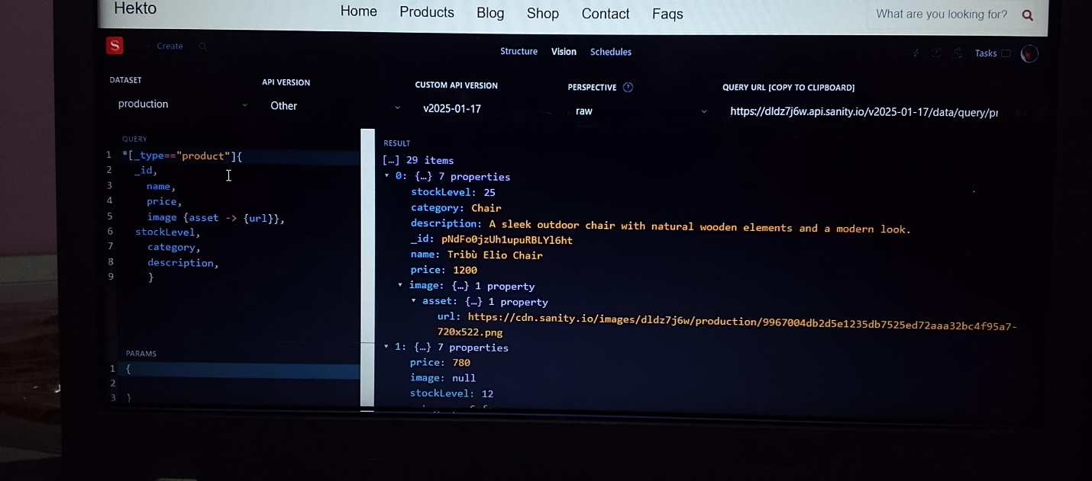

* **Creating Schema in Sanity**

1. 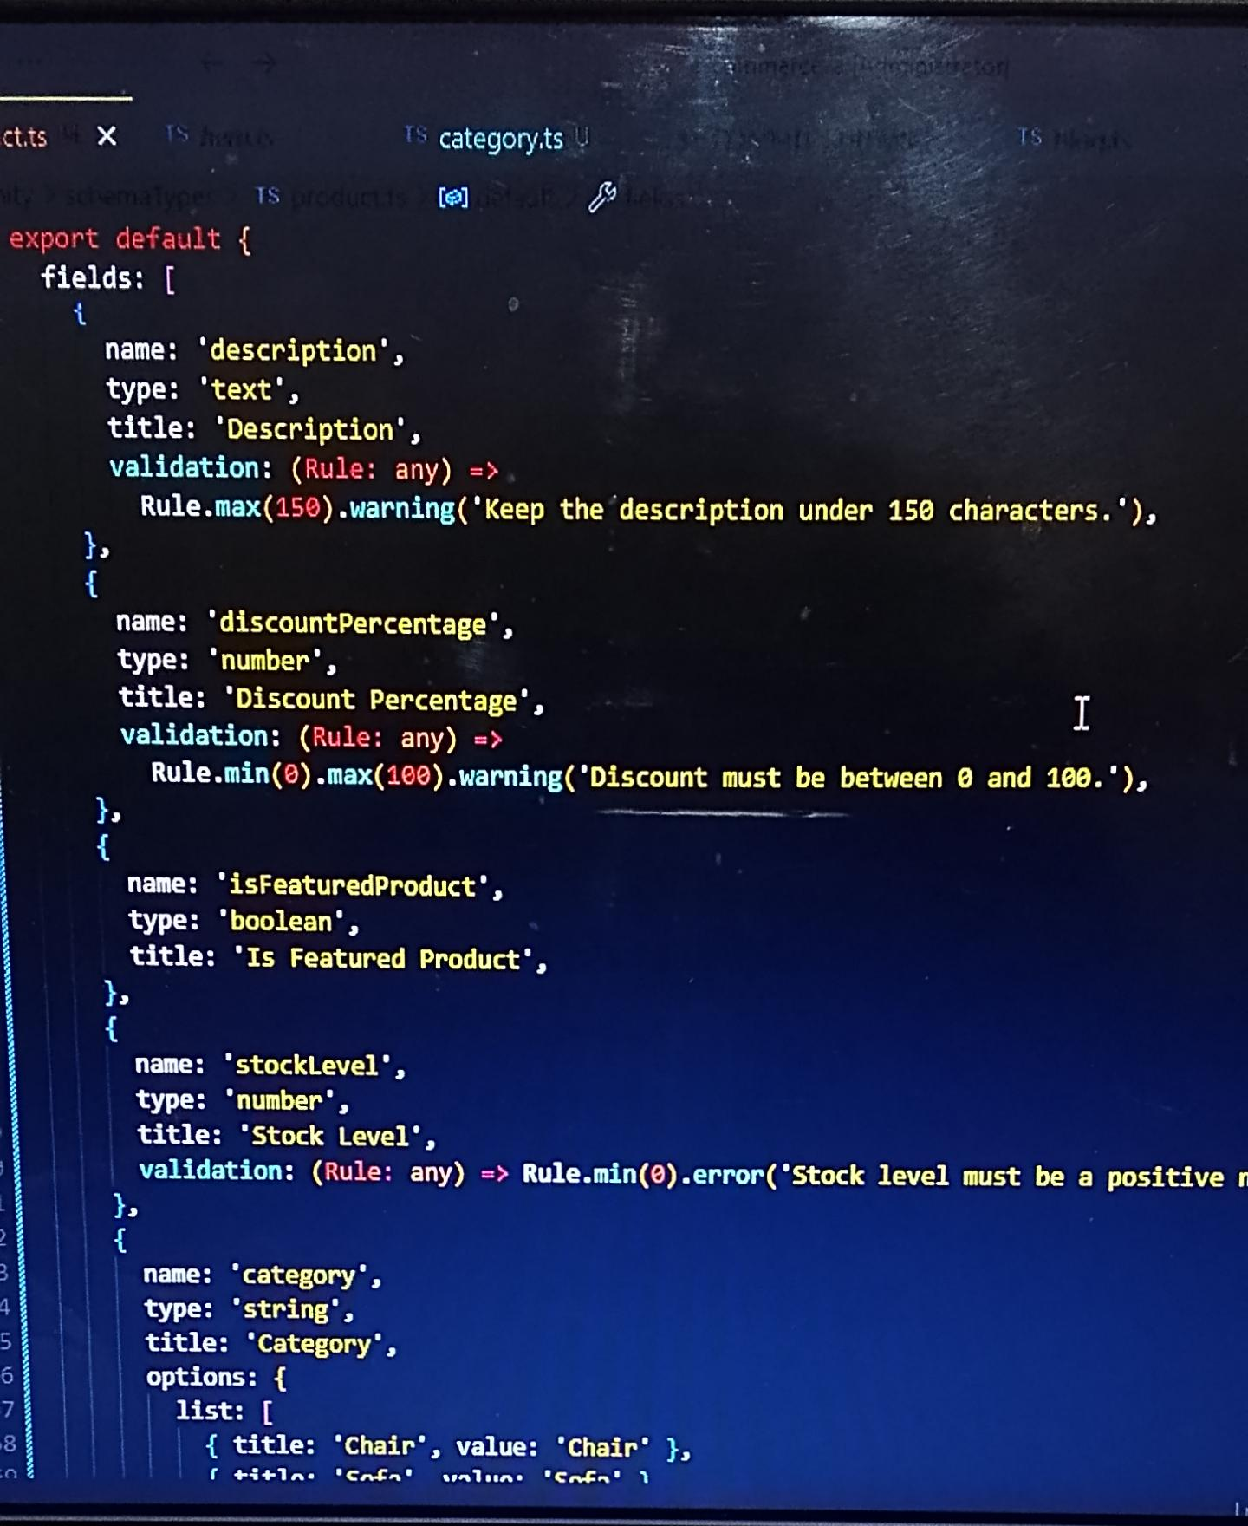**Define a schema for the products in your Sanity Studio project.**
2. **Save the schema file and re-run your Sanity project.**
3. **Fetching Data from Sanity**
4. **Use the client.fetch() method in your project to retrieve the products data.**
5. **Example code:**

**const query = `*[_type == “product”]`;**

**const product = await client.fetch(query);**

* **Importing Data into the Project**

1. **Map the fetched data into your frontend application.**
2. **Example**

**Import React, { useState, useEffect } from ‘react’;**

**Const Products = () => {**

**Const [products, setProducts] = useState([]);**

**useEffect(() => {**

**const fetchData = async () => {**

**const query = `*[_type == “product”]`;**

**const result = await client.fetch(query);**

**setProducts(result);**

**};**

**fetchData();**

**}, []);**

**Return (**

**<div>**

**{products.map((product) => (**

**<div key={product._id}>**

**<h2>{product.title}</h2>**

**<p>{product.description}</p>**

**<p>${product.price}</p>**

**<img src={product.image?.asset?.url} alt={product.title} />**

**</div>**

**))}**

**</div>**

**);**

**};**

**Export default Products;**

**Testing the Integration**

1. **Start the development server:**

**Npm start**

1. **Navigate to the relevant page on the website where products are displayed.**
2. **Confirm that all products are rendered correctly with their respective title, description, price, and image.**

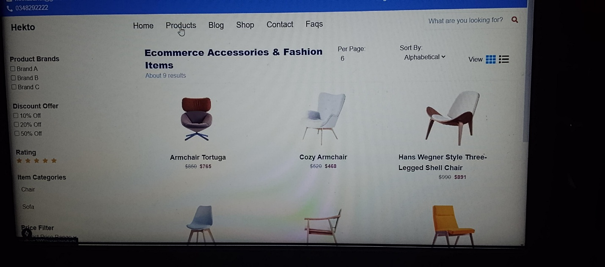

**Conclusion**

**The API integration for the e-commerce website has been successfully completed. Data from Sanity CMS is now dynamically fetched and displayed on the website. Further enhancements can include filtering, sorting, and adding interactivity to product displays.**

**Prepared by: Ashbah sami**

**Date: 18- janua-2025**